**Brooklyn torah gazette**

**For chanukah 5781**

Volume 5, Issue 13 (Whole Number 213)

25 Kislev – 4 Tevet 5781/ Dec. 11 - 18 2020

**Printed L’illuy nishmas Nechama bas R’ Noach, a”h**

This means, if one doesn't provide food to those who need it, he is held responsible for everything wrong that happens due to this error.

**What Is Hanukkah?**

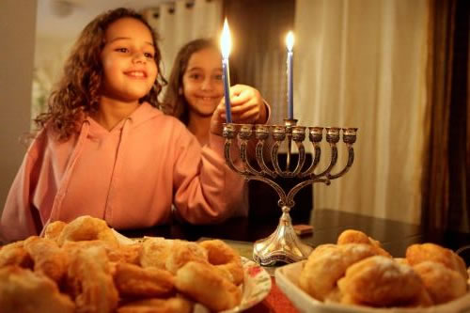

**Photo credits: Flash90**

Chanukah is the Jewish eight-day, wintertime “festival of lights,” celebrated with a nightly menorah lighting, special prayers and fried foods.

The Hebrew word Chanukah means “dedication,” and is thus named because it celebrates the rededication of the Holy Temple (as you’ll read below). Also spelled Hanukkah (or variations of that spelling), the Hebrew word is actually pronounced with a guttural, “kh” sound, kha-nu-kah, not tcha-new-kah.

**What Chanukah Commemorates**

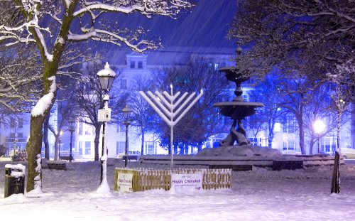

**Artist Dominic Alves captured this image of a snowy Chanukah in Brighton, UK.**

In the second century BCE, the Holy Land was ruled by the Seleucids (Syrian-Greeks), who tried to force the people of Israel to accept Greek culture and beliefs instead of mitzvah observance and belief in G‑d. Against all odds, a small band of faithful but poorly armed Jews, led by Judah the Maccabee, defeated one of the mightiest armies on earth, drove the Greeks from the land, reclaimed the Holy Temple in Jerusalem and rededicated it to the service of G‑d.

When they sought to light the Temple's Menorah (the seven-branched candelabrum), they found only a single cruse of olive oil that had escaped contamination by the Greeks. Miraculously, they lit the menorah and the one-day supply of oil lasted for eight days, until new oil could be prepared under conditions of ritual purity.

To commemorate and publicize these miracles, the sages instituted the festival of Chanukah.

**How Chanukah Is Observed**

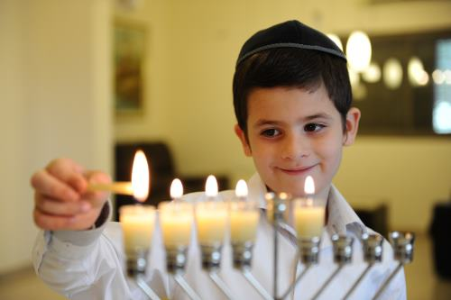

At the heart of the festival is the nightly menorah lighting. The menorah holds nine flames, one of which is the *shamash* (“attendant”), which is used to kindle the other eight lights. On the first night, we light just one flame. On the second night, an additional flame is lit. By the eighth night of Chanukah, all eight lights are kindled.

A menorah is lit in every household (or even by each individual within the household) and [placed in a doorway or window](https://www.chabad.org/holidays/chanukah/article_cdo/aid/1370967/jewish/Why-Is-Your-Menorah-not-in-the-Window.htm). The menorah is also lit in synagogues and other public places. In recent years, [thousands of jumbo menorahs](https://www.chabad.org/news/article_cdo/aid/2778619/jewish/How-the-Chanukah-Menorah-Made-Its-Way-to-the-Public-Sphere.htm) have cropped up in front of city halls and legislative buildings, and in malls and pa all over the world.

We recite the special Hallel prayer daily, and add [V’Al HaNissim](https://www.chabad.org/holidays/chanukah/article_cdo/aid/597182/jewish/Val-Hanissim.htm) in our daily prayers and in the Grace After Meals, to offer praise and thanksgiving to G‑d for “delivering the strong into the hands of the weak, the many into the hands of the few ... the wicked into the hands of the righteous.”

**When Is Chanukah?**

Chanukah begins on the eve of Kislev 25 and continues for eight days. On the civil calendar, it generally coincides with the month of December. Chanukah 2020 runs from Dec. 10-18.

**Chanukah Foods**

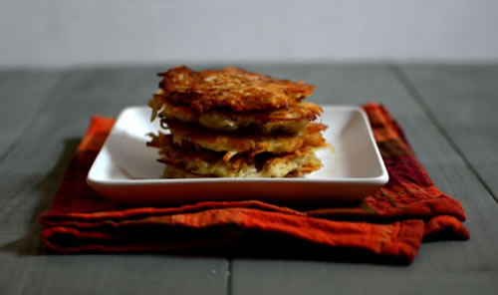

**Photo credit: Miriam Szokovski**

Since[the Chanukah miracle involved oil](https://www.chabad.org/holidays/chanukah/article_cdo/aid/796147/jewish/Why-All-the-Oil-and-Cheese.htm), it is customary to eat foods fried in oil. The Eastern-European classic is the potato *latke* (pancake) garnished with applesauce or sour cream, and the reigning Israeli favorite is the jelly-filled *sufganya* (doughnut).

**Dreidel: the Chanukah Game**

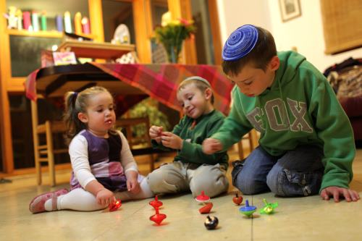

On Chanukah, it is customary to play with a “dreidel” (a four-sided spinning top bearing the Hebrew letters, *nun*, *gimmel*, *hei* and *shin*, an acronym for *nes gadol hayah sham*, “a great miracle happened there”). The game is usually played for a pot of coins, nuts, or other stuff, which is won or lost based on which letter the dreidel lands when it is spun.

**Chanukah Gelt**

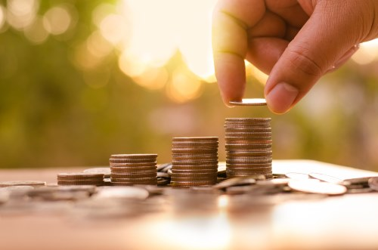

In today’s consumer-driven society, people tend to place great importance on giving Chanukah gifts. However, the tradition is actually to give Chanukah *gelt*, gifts of money, to children. In addition to rewarding positive behavior and devotion to Torah study, the cash gifts give the children the opportunity to give *tzedakah* (charity). This has also spawned the phenomenon of foil-covered “chocolate gelt.”

**What It Means For You**

Noting that one should spend time in close proximity to the Chanukah lights, the Previous Rebbe [of Lubavitch] would say, “We must listen carefully to what the candles are saying.” So what are the flickering flames telling us? Here are some messages:

a. Never be afraid to stand up for what’s right. Judah Maccabee and his band faced daunting odds, but that didn’t stop them. With a prayer on their lips and faith in their heart, they entered the battle of their lives—and won. We can do the same.

b. Always increase in matters of goodness and Torah-observance. Sure, a single flame was good enough for yesterday, but today needs to be even better.

c. A little light goes a long way. The Chanukah candles are lit when dusk is falling. Perched in the doorway, they serve as a beacon for the darkening streets. No matter how dark it is outside, a candle of G‑dly goodness can transform the darkness itself into light.

d. Take it to the streets. Chanukah is unique in that its primary mitzvah is observed in public. It’s not enough to be a Jew at heart, or even at home. Chanukah teaches us to shine outwards into our surroundings with the G‑dly glow of mitzvahs.

e. Don't be ashamed to perform mitzvahs, even if you will feel different. Rather, be like a menorah, proudly proclaiming its radiant uniqueness for all to see.

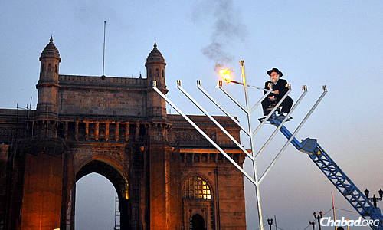

Rabbi Shimon Rosenberg of Afula, Israel, the father of Rivkah Holtzberg, lights a 25-foot steel menorah during Chanukah 2008 in front of the Gateway of India in Mumbai just weeks after his daughter and son-in-law, Rabbi Gavriel Holtzberg, were killed in a terrorist attack. Gavriel Holtzberg would light that menorah each year. (Photo by Serge Attal/Flash90)

**Rabbi Berel Wein**

**On Chanukah**

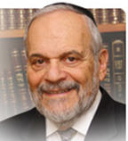

Now there is not much new or brilliant left to be said about the holiday of Chanukah, right? I think that maybe many old and grizzled rabbis like yours truly would probably agree with that statement. Over fifty years of writing and speaking about Chanukah should pretty much exhaust the topic, shouldn’t it? But then again that would be selling Chanukah short.

There is always a different and new insight that illuminates all of the holidays of the Jewish year and Chanukah is certainly no exception to this rule. I was reminiscing with myself (something that us old grizzled rabbis do often) about my own life and past.

**The Amazing Journey of a Chicago**

**Lawyer to a Jerusalem Rabbi**

I was amazed to again realize that somehow a lawyer from Chicago ended up being a rabbi in Jerusalem. How did this happen? And how did the Jewish state itself happen - not in terms of history, facts, personages, dates, places and wars – but in the amazing fact that such a state flourishes and progresses in spite of all odds, past and present, against its existence?

The rabbis of the Talmud have taught us that people to whom wondrous things occur do not really recognize those events as being wondrous. It is part of the weakness of human nature to have such limited understanding. There has to be a flash of insight, a commemorative act, a tradition of being able to look past the trees to the forest, a spirit of almost childlike wonder in order for the amazing to truly be believable in the eye and mind of the beholder. And I think that this is essentially how we have to look at Chanukah – as the historical event, as the commemoration of that event and of the traditions and customs that so endear this eight day festival to all of Israel.

**An Amazing Event that Might Otherwise**

**Been Seen at Being Ordinary and Natural**

Jewish tradition and the rabbis of the Mishna took an amazing event that many people would look at as being ordinary or natural and restored it to its truly wondrous state. The story of Chanukah is that of a small and apparently weak nation overcoming a mighty army of a world empire.

It records a triumph of monotheism and Jewish tradition over pagan culture and practices, of the small, pure lights in the Temple that overcame the flaming torches that were far from pure, and of the vitality and resilience of Israel over those who would wish to snuff it out of existence. It is all wondrous but only if one views it all as being wondrous.

The rabbis in their holy perspective of Jewish life and events elevated the mundane and seemingly ordinary to the realm of miraculous and eternal. That is basically the main lesson that Chanukah teaches us – that we are a special people who live a miraculous existence with constant wonder surrounding us and yet it is all encrusted in seemingly natural and ordinary occurrences.

To de-legitimize the story of Chanukah and to treat as just another ancient war of the Grecian period is the same tactic that the world uses today to de-legitimize the State of Israel and our rights to our ancient homeland. If the wonder of it all is lost and forfeited than so is our struggle for existence and independence. Chanukah is pure wonder and hence its importance and relevance to us in today’s world.

**Chanukah is a Children’s Holiday**

Perhaps more than other holidays of the Jewish year, Chanukah is a children’s holiday. Tradition allows even the youngest to light the Chanukah candles, to play dreidel, to taste latkes and sufganyot, to have time off from school and to observe the holiday through the eyes and senses of a child.

Children still retain their sense of wonder and imagination. Their world is not usually bound by the practicalities, realism and sometimes pessimism of their elders. Everything in life is still new and unexpected, worthy of curiosity and examination. Theirs is yet a magical world, even a spiritual world, viewed from a different plane of perception and thought.

Therefore, Chanukah is the perfect holiday for children for it requires this perspective - to be made wondrous, miraculous and thereby meaningful and beneficial. Chanukah is not for the jaded and empty spirited. Its candles flicker only for those that see the fire of Torah, tradition and morality that lies beneath their small surfaces.

One who is privileged and able to see the wonder of the events that occurred to us “in those days” will also be able to discern the wonders that we encounter daily here in Israel “in our time.”

Shabat shalom. Chanukah sameach

*Reprinted from the website of Rabbiwein.com*

**Chanukah Musings**

**By Rabbi Moshe Meir Weiss**

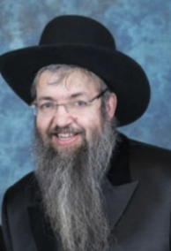

Let me share with you some short Chanukah thoughts to add extra sparkle to your Chanukah - to go with the delicious latkas, cheese platters, and sufganiot.

1. Speaking about sufganiot which are those delicious confections that we imported from Eretz Yisroel. (When I was growing up, all I’d ever knew of was latkes, sour cream and apple sauce.  I’d never even heard of sufganiot.)  I assumed that the reason why there is a *minhag* to eat these delicious donuts is because they are deep fried so it once again - like latkas - helps us recall the miracle of the oil.  However, Rav Shach, Zt”l, Zy”a, reveals another fascinating angle to this custom.  He explains that we eat them in order to be able to make the after-blessing of Al HaMichyah, which is the only blessing that mentions the Mizbei’ach, the Altar.  Since on Chanukah, the Chashmonaim joyously rededicated the Mizbei’ach, we make it our business to say this blessing.

**The Infamous Decrees of the Y’vonim**

2. One of the infamous decrees of the Y’vonim, the Syrian-Greeks, was “Kisvu lachem al karnei ha-shor, ‘Ein li cheilek b’Elokei Yisroel’ - Write on the horns of your ox, ‘I have no portion in the G-d of Israel.’”  The Yavonim tried to influence us into believing that our livelihood (symbolized by the ox since we were an agricultural economy) had nothing to do with Hashem.  We, of course, as we celebrate Chanukah, note to the contrary that our *parnassah* has everything to do with G-d and since we believe that on *Zos Chanukah*, the eighth day of Chanukah, the final annual verdict is rendered, this makes Chanukah a good time to pray heartily for financial success.

3. Rabbi Frand, Shlit”a, adds that in ancient times they fashioned baby bottles from horns.  It was the desire of the Y’vonim that we inculcate our young with the spirit of atheism.  Therefore, as we celebrate Chanukah, which has at its very root the word *chinuch*, education, we try to impress even upon our very youngest the spirit of Hashem and His miracles that permeate this very special time.

**A Superb Feeling to Know that We Are Doing**

**Exactly What We Were Created to be Doing**

When we kindle the menorah at the right time, whether it’s *shkiah* or forty-five minutes after shkiah, it’s a superb feeling for we know at that moment that we are doing exactly what we were created to be doing.  As the posuk says, “Davar b’ito, mah tov - A thing in its proper time, how good it is.”  Therefore, we should be vigilant that Chanukah parties should be worked around the menorah and not vice versa.

The Chanukah *dreidel*: its rules are simple.  *Gimel*, you win; *hei*, you get half; *nun* is nothing and *shin* you pay.  The rules are puzzling, however, since we would think that the *nun* should be the big winner since it means *neis*and represents the big miracle.  I’d like to suggest that gimel, which stands for *godol*, great, is the big winner because those of us who have an ambition to be great as we spin through life, whether to be great with G-d, great with our spouse, great with our children, great in learning, or great in prayer, are the true winners in life.

Those who just coast through life on cruise control are in the loser’s corner.  The next best letter is *hei* which stands for*hoyah*, what happened in the past, for the true winners in Yiddishkeit are not those who are enamored by modern technology and enraptured by all that is new.  Rather, real success is for those who are connected to the sacred teachings of Sinai from thousands of years ago.

The dreidel toy was used by the children in case a Syrian-Greek inspector would come to catch them learning Torah.  As soon as they heard ominous footsteps, they would hide their Chumoshim (yet others suggest that they studied by heart) and pull out their Chanukah spinning tops.  The message is clear:  Torah is more important than playing and not vice versa.  We should bear this in mind on Chanukah before cancelling our scheduled Torah study sessions.  For example, make an effort to go to your Motzoei Shabbos Avos u’Bonim learning before going to a Chanukah gathering.

**The Lesson of the Dreidel**

You can’t win with the dreidel while it’s spinning.  Only when it falls on its side do you know whether you’ve won or lost.  As long as we are alive we don’t know whether we are in the winner’s column.  As we are taught, Al tamin. b’atzmocha ad yom moscha - Don’t trust in yourself until the day you die.”  We must be ever vigilant from the many temptations that abound around us.

It is only when we are lying on our side after one hundred and twenty that we will truly know if we’ve won or lost in the game of life.  On the other hand, the dreidel also teaches us the great Jewish lesson that if you fall, pick yourself up and try again.  As the ethicists wittingly say, yiush  shelo m’das - Giving up means you’re not using your head.”  We Jews are compared to the moon which is always changing and always renewing itself.

The Menorah does not have halogen bulbs or mercury vapor lights.  It does not have fancy reflectors and neither does it boast powerful wattage.  To the contrary, it is a rather relatively pathetic, outdated pool of oil with an antiquated wick inside.  But, that is precisely its powerful message.  The glow in our homes is not from the new world whose morals and values are rapidly disintegrating around us.  Rather the illumination that brightens our homes is from the Divine ancient wisdom handed down to us from generation to generation.

**What is Menorah Power?**

What is menorah power?  When someone from a kiruv organization such as Oorah sees a menorah in a window and because of it rings the doorbell and offers a child a Chanukah toy and invites them to try out yeshiva, this two thousand year old ritual is sending out a beacon to alleviate the threat of *l’hashkichom Torosecha*, the forgetting of the Torah, as it was thousands of years ago during the time of Chanukah itself.

Dear Readers, May you and yours have a healthy, happy, sweet and wonderful Chanukah.

*Reprinted from the December 16, 2014 website of Matzav.com*

**Four Powerful Insights from the Lubavitcher Rebbe – Chanukah**

[**Compiled by Mordechai Rubin**](https://www.chabad.org/search/keyword_cdo/kid/21532/jewish/Rubin-Mordechai.htm)

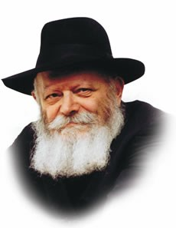

The name Chanukah comes from the word chinuch, which means "inauguration." Chanukah celebrates the renewal of the service in the Holy Temple after it was liberated from the Greek defiler, purified, and rededicated as the seat of the divine presence in our world.

Chanukah serves as a model for all inaugurations, including the most significant inauguration of all—education, a child’s inauguration into life (indeed, chinuch is also the Hebrew word for "education"). The uncompromising insistence on purity and perfection which Chanukah represents holds an important lesson regarding the essence of the educator's task.

Compromise is anathema to education. To a mature tree, a gash here or a torn limb there is of little or no consequence. But the smallest scratch in the seed, the slightest nick in the sapling, results in an irrevocable deformity, a flaw which the years to come will deepen rather than erase.

Virtually every life is faced with demands for compromises—some tolerable, others not. The educator who wishes to impart a set of values and priorities that will weather them all, must deliver, in word and example, a message of impeccable purity, free of even the slightest and most acceptable compromise.

**Light!**

Light, brightness, radiance, are metaphors we use when we wish to speak about hope, wisdom, or goodness. The candle flame, the ray of light, the glowing coal — these are the images in which we recognize our yearning for a better world, for a wiser, more virtuous, more G‑dly self.

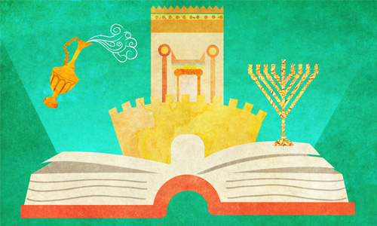

**Illustration by Sefira Ross.**

We are encouraged by the fact that a luminous body like the sun, can have such a profound effect on entities and beings millions of miles away, enriching them with light, warmth, energy and life. We are encouraged by the fact that a tiny flame can banish a roomful of darkness. If so, all is not lost. If our own souls are "candles of G‑d", then little me is not so little after all. All we need to do is be what we truly are, to act out our innate goodness, and the darkness will melt away.



Once a year, we celebrate this truth. For eight days and nights, we celebrate the power of light: in ascending number — one little flame on the first evening, two flames on the second, three on the third — we kindle the Chanukah menorah, recalling that miraculous victory, 22 centuries ago, of quality over quantity, spirit over materialism, right over might. And pray for the day when such victories are no longer "miracles", but the way things are in G‑d's world.

**A Cruse of Oil**

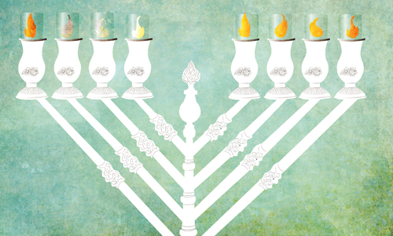

Every individual has his “one cruse of oil,” begging to be discovered. A person may not uncover this internal connection to G‑d in the ordinary circumstances of his life. But when challenged, as in the case of the Maccabees, this inner connection will surface. And when this divine bond comes to the fore, “[G‑d will] deliver the mighty into the hands of the weak, the many into the hands of the few,” for nothing can withstand its power.

In their struggle against the Greeks, the Maccabees tapped this resource - this single cruse of oil, revealing a level of soul that transcended their usual limits. In response, G‑d revealed miracles that transcended the natural limits of this world.

The Chanukah miracle which followed serves as an eternal testimony to the essential connection to G‑d that the Greeks sought to sever. In our day as well, the Chanukah lights remind us that through an appreciation of the infinite G‑dly, dimension of the Torah and its commandments, we can kindle the potential for light we all possess within our souls.

**Striving Higher**

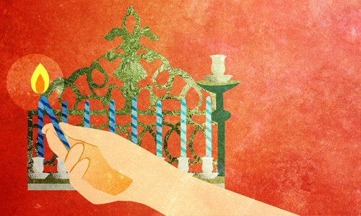

**Illustration by Sefira Ross**

It's luminous, it's warm, it's romantic; but most of all it's spiritual. A yellow droplet of light, laced with red, bright-white at the edges, and blue at the core as if dirtied by its contact with the material wick. But we didn't see all those colors until we counted them — the flame itself is a perfect, integral whole, emanating calm and tranquility.

How, indeed, can something as agitated as the flame radiate such peace? A flame is a clash of forces pulling in opposite directions. Back and forth, up and down it strives, vacillating between being and naught, between presence and oblivion.

"The soul of man is a candle of G‑d" ([Proverbs 20:27)](https://www.chabad.org/16391#v27). For the soul of man, too, is a clash of divergent forces and contrary strivings.

We yearn to tear free of our "wick" — of the body that anchors us to the physical reality and sullies us with physical needs and wants. We strive upwards, yearning to transcend the physical, and fuse with the universal and the divine. At the same time, we cling to the body, to the bit of matter that sustains us as dynamic and productive participants in G‑d's world.

It is this perpetual up-and-down, this incessant vacillation from selfhood to selflessness and back again, that we call life. It is this eternal tension between our desire to escape the physical and our commitment to inhabit it, develop it and sanctify it that makes us spiritual beings.

We can sit and gaze at the flame for hours, because we are gazing at ourselves.

**The Chanukah Battle Continues**

The Chanukah battle and victory were immortalized by the Sages. The candles evoke the memory of the small group of Jews who fought those who had opposed the Torah. Today, we each battle our own evil inclination as well. Our victories, as well, will be eternally remembered. Our current mission and battle is for the coming of Moshiach, as we request three times a day during prayer. Although we only request his coming three times a day, we yearn for him “all day”!

*Reprinted from the Chanukah website of Chabad.Org*

**Chanukah**

**G-d Fights Our Wars:**

**The Miracle of the Oil**

**By Rabbi Bentzion Shafier**

**Founder of TheSmuz.com**

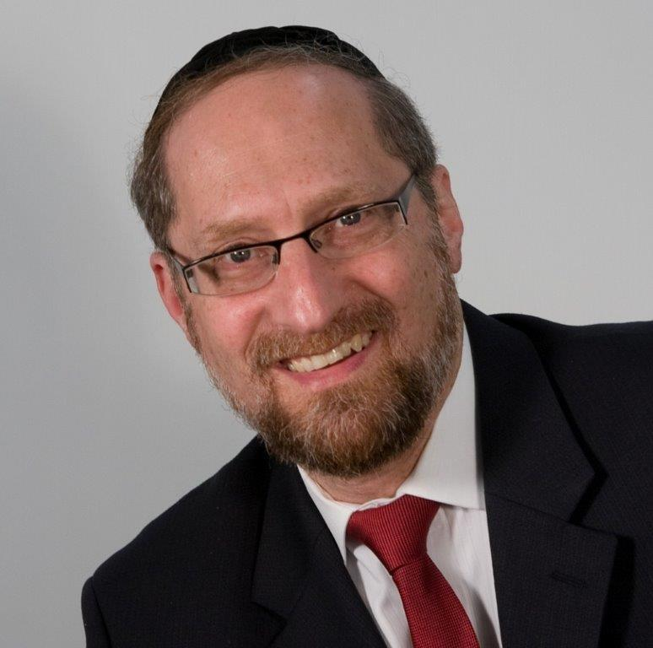

**Why Do We Celebrate Chanukah?**

*“When the Yivanim entered the Bais HaMikdash, they defiled all the oil set aside for lighting the Menorah. When the Chashmonoim were victorious, they searched and were able to find only one small jug of oil with the Kohain Gadol’s seal intact. It had sufficient oil to last only one day, but miraculously it lasted eight days. In honor of the miracle of the oil lasting eight days, Chazal inaugurated these days for Hallel and thanksgiving.”* — Gemara Shabbos 21b

**Al Ha’Nisim: The Miracle of the Battle**

The Maharal states that this Gemara seems to contradict what we say in *Al Ha’Nisim*, a *tefillah* that was written by the *Tanaim* hundreds of years before. In the *Al Ha’Nisim*, we proclaim thanks to HASHEM for the miracle of the war. We thank HASHEM for delivering the Yivani armies into our hands. “You fought their battles, judged their judgments, took their revenge. You put the mighty into the hands of the weak, the many into the hands of the few…” According to the *Al Ha’Nisim*, the miracle of Chanukah was that HASHEM delivered us from the armies of the Yivanim. Yet the Gemara in Shabbos says that we celebrate Chanukah because of the miracle of the oil lasting eight days. The Maharal asks, “Which one is correct?”

The miracle of the oil revealed the miracle of the war.

The Maharal answers that both reasons are true, and both are consistent with each other. The actual event for which we give thanksgiving and sing Hallel is the salvation of the Jewish people. We won a war against all odds. However, it wasn’t clear that the victory was a miracle. To people living in those times, the military success seemed to be natural. It was attributed to Jewish resilience and bravery.

## How could anyone not see the victory as a miracle?

It didn’t appear that HASHEM had delivered us from the hands of the Yivanim; rather, it appeared as *“*their might, and the strengthof their arms*.”* It was only through the miracle of the oil that they came to understand the miracle of the battle. Once people saw the oil last eight days – an overt miracle from HASHEM — they then came to see that their success on the battlefield was from HASHEM as well. The miracle of the oil revealed to them the miracle of the war.

Israel didn’t have a standing army

This Maharal becomes difficult to understand when we take into account a basic historical overview.

**Living Under the Reign of Gentile Monarchies**

The events of Chanukah take place around the middle of the era of the Second *Bais HaMikdash*. From the time that Bavel destroyed the first *Bais HaMikdash* up until that point, the Jewish people lived under the reign of gentile monarchies. Our right to exist and our form of self-government was decided by the ruling parties. We were a vassal state under foreign rule, and when the Yivanim entered Yerushalayim, the Jewish people did not even have a standing army.

This wasn’t a war of a stronger army against a weaker opponent. It was a war in which the most powerful empire in the world was pitted against a band of unorganized, unarmed, private citizens.

While the war itself lasted three years, during the entire first year of fighting, there were no formal battles. Two armies were not squaring off against each other; there was no Jewish army. The fighting consisted of guerrilla skirmishes. Some Jews would sneak up on a lone detail of Yivani soldiers, kill them, and take their arms. Bit by bit, more Jews would join Yehudah Ha’Macabi, but at every point during the war, the Jews were far outnumbered, outgunned, and preposterously less battle-ready than their enemies.

**The Leaders of the Rebellion were Kohanim**

Even more startling is that almost all of the original fighters had no battle experience. The leaders of the rebellion were *Kohanim*. A *Kohain* is a Torah teacher, one who serves in the *Bais HaMikdash*, one who guides the *klal* *Yisroel* in *ruchniyus* (spiritual matters). He isn’t a soldier. So this was a war led and fought not by soldiers, but by *roshei yeshiva*. It was akin to Reb Shmuel Kaminetsky leading the Lakewood Yeshiva in battle against the US Marine Corps.

**How Could Anyone Not See the Miracle of the War?**

No intelligent assessment of the situation would have predicted a Jewish victory. How then is it possible that the Jews at the time saw these events as anything other than the miracles that they clearly were?

**This Seems to be Natural to the Human**

The answer to this question seems to be that when one is many years away and far removed, he gains a historical vantage point. He is able to see an event in context and can easily recognize it as a miracle. But to those living in the day-to-day heat of the battle, it is much more difficult to see the event from that perspective.

To those involved, it seemed to be a natural course of events. Granted the odds were slim, but the Jews won. Skirmish after skirmish, battle after battle, the Macabees came out victorious. There is no question that they did well, which is why it seemed that their skill, their cunning, and their wisdom in battle won those wars. And as such, to people living in those times, the miracle was hidden. And then a single event focused their sight.

When the *Kohanim* returned to the *Bais HaMikdash* and took out that little bit of oil that couldn’t possibly last for eight days and watched it remain aglow night after night, everyone knew it was miraculous.

When they experienced the miracle of the oil, it reshaped the previous three years in their minds. Then they could see the battles themselves as the miracles that they were. Exactly as the Maharal said, “*The miracle of the oil revealed the miracle of the battle.*”

**We See the Same Phenomena in Our Times**

In our own times, we witness an eerie parallel to these events and to the same mistaken interpretation.

For almost two thousand years we have existed as a lone sheep amongst seventy wolves. Universally hated and oppressed, the Jewish people have survived. And now, after almost 1900 years of wandering, we find ourselves back in our own land.

Since 1948, the Jewish nation has witnessed profound miracles in the repopulation and development of the land of Israel. But it is the survival of our people that is the greatest miracle.

In 1948, the population in the Middle East numbered roughly 650,000 Jews, surrounded by some 50 million Arabs. On May 15th, 1948, one day after the State of Israel was declared, five nations attacked, each with well-trained armies and air forces, each alone capable of annihilating the small band of Holocaust survivors. At the time there was no Jewish army, navy or air force. Yet, against all odds, we won that war, and against all odds we continued to win war after war – until now, ironically, when the Jews are considered the superpower in the region.

To most people, Jew and gentile alike, it seems that this is just the way of the world. To the average witness to these events, it isn’t a demonstration of the hand of HASHEM. It is just the ebb and flow of history.

The lesson of Chanukah is to see behind the veil of nature, to tune our sight into the true cause of events, and to see that it is HASHEM Who runs the world and fights our wars – then as now.

*Reprinted from this week’s website on TheShmuz.com*